**Drawer navigation**

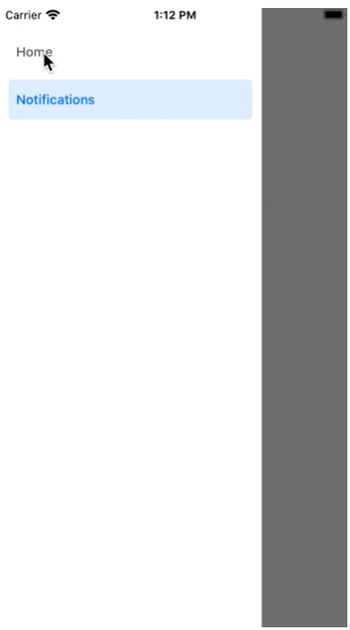

import * as React from 'react';

import { Button, View } from 'react-native';

import { createDrawerNavigator } from '@react-navigation/drawer';

import { NavigationContainer } from '@react-navigation/native';

function HomeScreen({ navigation }) {

return (

<View style={{ flex: 1, alignItems: 'center', justifyContent: 'center' }}>

<Button

onPress={() => navigation.navigate('Notifications')}

title="Go to notifications"

/>

</View>

);

}

function NotificationsScreen({ navigation }) {

return (

<View style={{ flex: 1, alignItems: 'center', justifyContent: 'center' }}>

<Button onPress={() => navigation.goBack()} title="Go back home" />

</View>

);

}

const Drawer = createDrawerNavigator();

export default function App() {

return (

<NavigationContainer>

<Drawer.Navigator initialRouteName="Home">

<Drawer.Screen name="Home" component={HomeScreen} />

<Drawer.Screen name="Notifications" component={NotificationsScreen} />

</Drawer.Navigator>

</NavigationContainer>

);

}